SET ASSIGNMENT

1. Write a Python program to create a set.

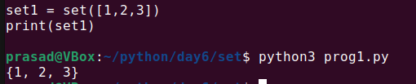

2. Write a Python program to iterate over sets.

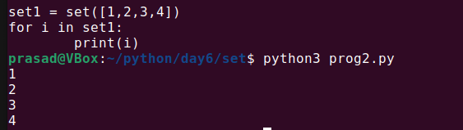

3. Write a Python program to add member(s) to a set.

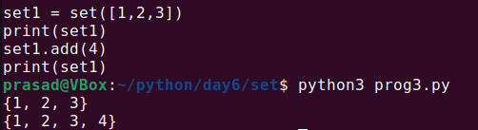

4. Write a Python program to remove item(s) from a given set.

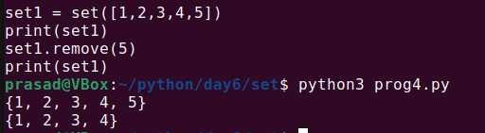

5. Write a Python program to remove an item from a set if it is present in the set.

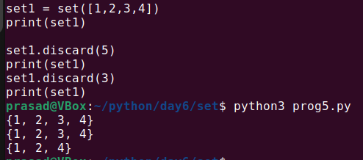

6. Write a Python program to create an intersection of sets.

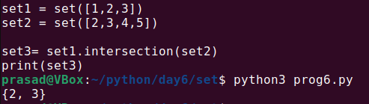

7. Write a Python program to create a union of sets.

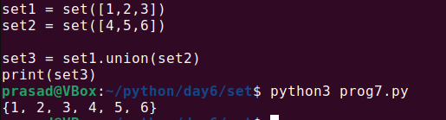

8. Write a Python program to create set difference.

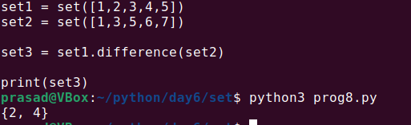

9. Write a Python program to create a symmetric difference.

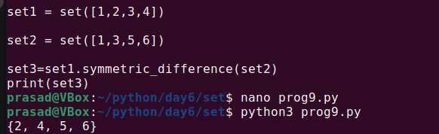

10. Write a Python program to check if a set is a subset of another set.

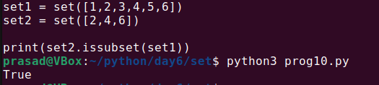

11. Write a Python program to create a shallow copy of sets.

Note : Shallow copy is a bit-wise copy of an object. A new object is created that has an exact copy of the values in the original object.

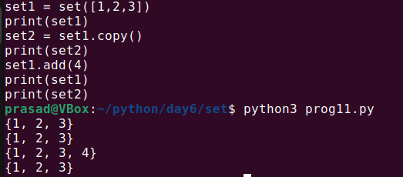

12. Write a Python program to remove all elements from a given set.

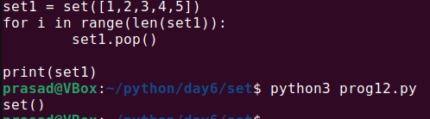

13. Write a Python program that uses frozensets.

Note: Frozensets behave just like sets except they are immutable.

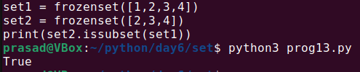

14. Write a Python program to find the maximum and minimum values in a set.

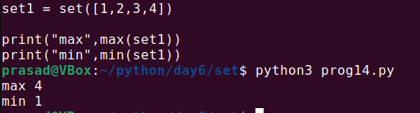

15. Write a Python program to find the length of a set.

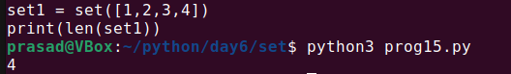

16. Write a Python program to check if a given value is present in a set or not.

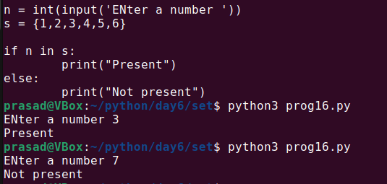

17. Write a Python program to check if two given sets have no elements in common.

18. Write a Python program to check if a given set is a superset of itself and a superset of another given set.

19. Write a Python program to find elements in a given set that are not in another set.

20. Write a Python program to remove the intersection of a second set with a first set.

21. Write a Python program to find all the unique words and count the frequency of occurrence from a given list of strings. Use Python set data type.

22. Write a Python program that finds all pairs of elements in a list whose sum is equal to a given value.

23. Write a Python program to find the longest common prefix of all strings. Use the Python set.

24. Write a Python program to find the two numbers whose product is maximum among all the pairs in a given list of numbers. Use the Python set.

25. Given two sets of numbers, write a Python program to find the missing numbers in the second set as compared to the first and vice versa. Use the Python set.

26. Write a Python program to find all the anagrams and group them together from a given list of strings. Use the Python data type.

27. Write a Python program to find all the anagrams in a given list of strings and then group them together. Use the Python data type.

28. Write a Python program to find all the unique combinations of 3 numbers from a given list of numbers, adding up to a target number.

29. Write a Python program to find the third largest number from a given list of numbers.Use the Python set data type.

30. Write a Python program to remove all duplicates from a given list of strings and return a list of unique strings. Use the Python set data type.